Task 12: Log Monitoring & Analysis
1.Understand log types.
- Logs record system, user, and application activities.
- Linux logs include authentication logs (auth.log), system logs (syslog), and application logs.
- Windows logs include Security, System, and Application logs.
- Different log types help detect login attempts, errors, and suspicious activities.
- Understanding log types is essential for monitoring and incident detection.

2.Analyze authentication logs.
windows
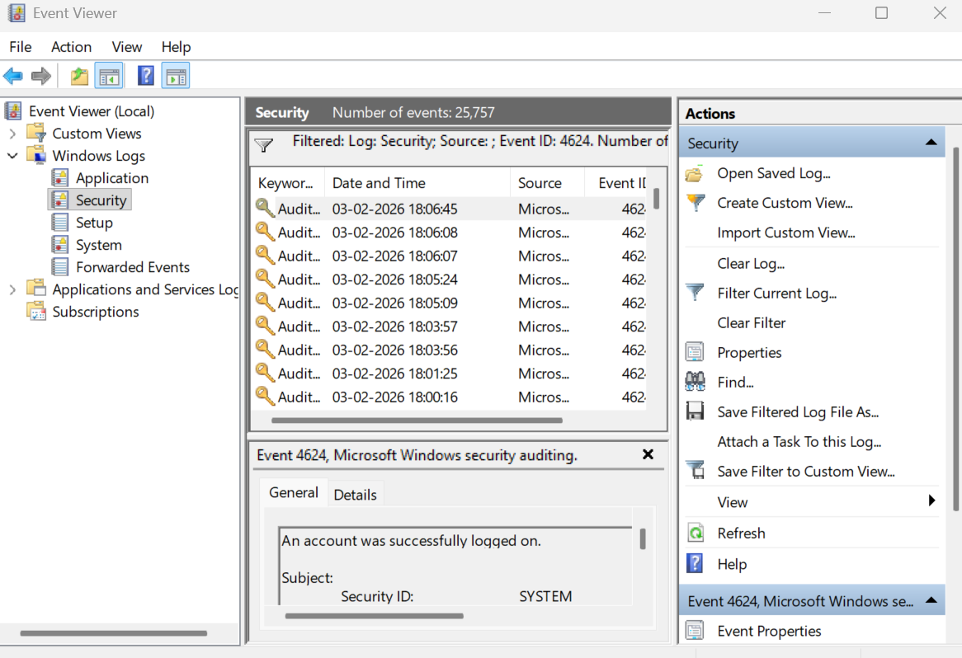
Linux
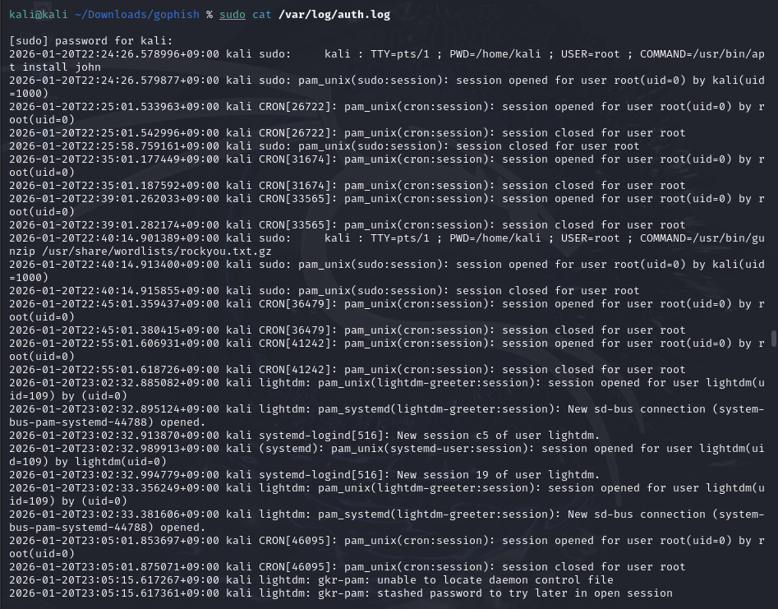
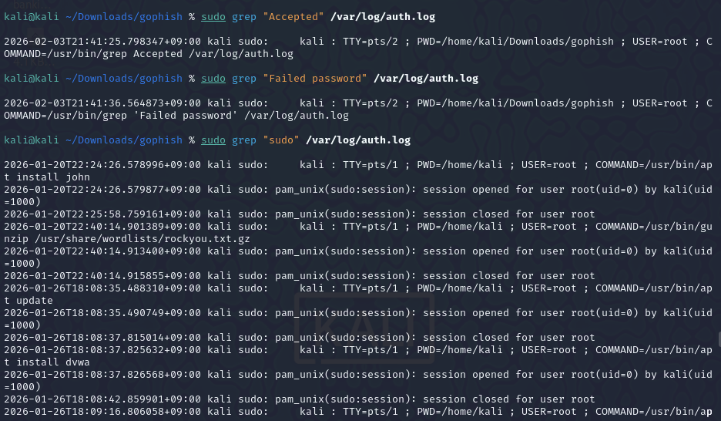
3.Identify failed logins.
Linux
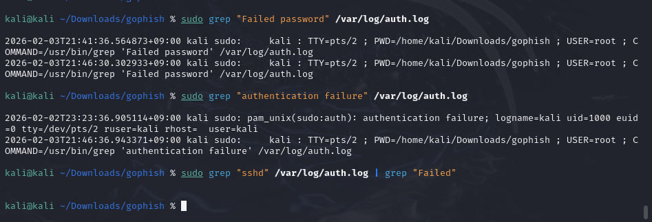
Windows
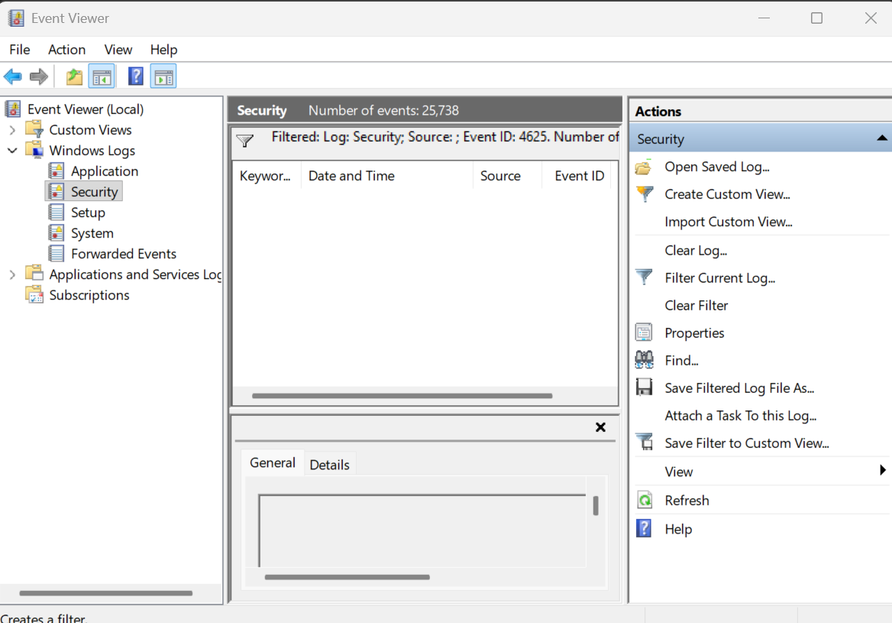

4.Detect anomalies.
Linux
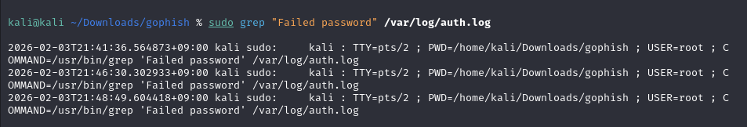
Windows
5.Correlate events.
Linux
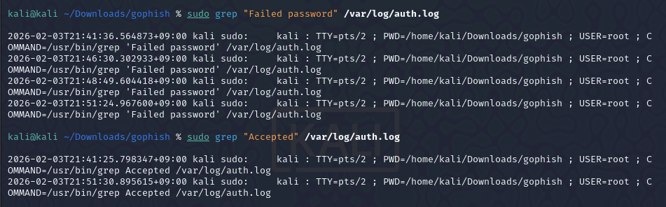
Windows
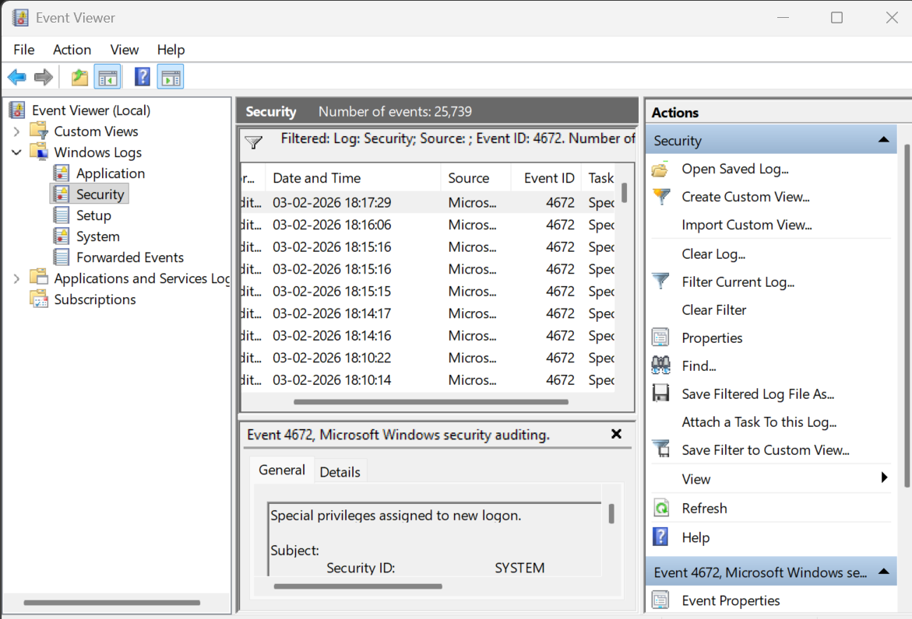

6.Learn SIEM basics.
What is SIEM?
SIEM stands for Security Information and Event Management.
It is used to collect, analyze, and correlate logs from multiple systems in real time.
What SIEM Does
- Collects logs from servers, applications, and network devices
- Correlates events to detect security incidents
- Generates alerts for suspicious activity
- Helps in incident investigation and compliance
Examples of SIEM Tools
- Splunk
- ELK Stack (Elasticsearch, Logstash, Kibana)
- IBM QRadar
- ArcSight

Why SIEM is Important
- Detects attacks early (brute force, malware, insider threats)
- Centralizes log monitoring
- Reduces manual log analysis effort

7.Write alerts.
When to Trigger Alerts
- Multiple failed login attempts
- Login from an unknown IP
- Successful login after many failures
- Unexpected sudo/admin access
- Activity outside normal working hours

Conclusion
Linux and Windows authentication logs were analyzed to identify login activities and failed authentication attempts. The logs showed a few failed sudo password attempts and multiple successful authorized logins, indicating normal system usage. No signs of brute-force attacks or unauthorized access were detected. This analysis demonstrates how log monitoring helps identify suspicious activity and supports effective incident detection.

